George Bishop

CIS 236

November 3, 2022

**Storyline Prototypes**

**Story (Mystery)**

Story Setting: AOL chatroom / some chatroom in general

Game interface: JComponent mock chatroom (mock search engine?)

Story: The links hit like the locusts of Ancient Egypt. One day nothing, the next day near a third of all chat rooms had been spammed with links. Not one after the other, but pasted and sent at odd intervals. In fact, they only popped up when the boards were active. These links lead to different websites of seemingly disconnected subjects. In the beginning, the sites appeared benign. In turn, a portion of users took to exploring the links. While not widely useful, the niche needs of some chatters lead to the websites being a helpful resource. But it was at this point that disaster struck. An avid user of a soccer message board had their savings drained. From what he could tell, $62,000 evaporated. It was not even until two days later that he noticed the receipt in his Gmail inbox. At 2:00am the day before last, a withdrawal was requested by nobody but himself. At least, that is what the email indicated. In a panic, he called the bank to report the incident. And, transported to a Kafkaesque hell discovered that there was nothing he could do. According to the bank, paperwork from the transaction had been submitted a week ago. All the requisite credentials had been presented and the withdrawal was final. The bank shut and locked the door. Of course, this was only the beginning for the victim. Next, he contacted the police and reported the incident. Motivated by the accusation’s scale, a case was opened into the transaction. A week passed before the user heard back from the department. Over this period the soccer chat room lit up. The now destitute user told all his contacts about the incident. Nothing could explain why this had happened. 7 days later, the police responded. Foul play was not indicated. Moreover, the man he spoke with threatened an IRS investigation into him for attempted fraud. The chatter was left with nothing but his belongings. The small group that was informed about the incident kept it to themselves. It was a tragedy no doubt, but seemingly just random misfortune. It was a friend going through a hard time, end of story. 3 weeks passed without news. Everybody operated normally; some continuing to use the spammed sites. 25 days after the last incident, another occurred. A different user, a different place, the same chat site. The circumstances were also the same. $134,000 stolen from a savings account. Paperwork submitted. No foul play indicated. The attacks persisted. It was after 11 uninitiated withdrawals that entire chat communities became aware of the bank account siege. First, the golf threads were familiar with it. Next, cruise meet up boards and soap opera chats. By time the classical music community was picked through, 28 users had been stolen from. No country appeared to be out of bounds either. Though this was not known at the time, the victims covered 13 countries in the west and 2 in the east. More and more communities shared in the information allowing the story to grow. Some altruistic users even began sending emails to the victims’ banks urging them to look more closely into the matter. Still, the massive institutions pugged their ears. All precautions had been taken; the victims had no ground to stand on. A year and a half of robbery, then silence. The attacks stopped. And while no justice came to pass, the messaging platform returned to normalcy. The shared experience became part of the site's lore and fossilized in history. That is until 3 months later when a new board is created by user m1key_m0use.

**Puzzle Pieces**

* What evidence needed for success:
  + Criminal identity
    - Required: Juliet Monet
    - Contingent on supplied required info: Colin Sullivan
  + Crime method
    - Required:
      * link spam = pharming operation
      * victim input → identity theft
    - Contingent on supplied required info:
      * Method of true identity obfuscation
      * Active proof suppression
* All provided evidence:
  + Victim testimony
  + Victim demographics
  + Potential pharming website info:
    - User information required by website
    - Domain registration time/date
    - Web platform/registrar
    - Connected links
    - Supported languages
    - Event action
    - Event actor
    - Event time/date (can be future dated)
    - Server host name + IP
  + Time frame
  + Unique attack style
    - Limited cases of similar past attacks
    - Past attacks are over 2 years old
    - Past attacks are few over short time period(Juliette testing attack methods)
    - Suspect list
  + Evidence removal
    - Websites taken down
    - Victims go inactive
  + Incident scope
    - Unique to chatroom platform
    - Targeted towards select message boards
* Evidence locations:
  + Irene
  + Colin
  + Pharming websites
  + Past attack description website
  + Chatroom user lookup
  + Victim testimony screenshots
* Character provided evidence:
  + Colin (unhelpful at first):
    - RDAP info
    - Victim demographic statistics
  + Mikey (anecdotal attack info):
    - Time frame
    - Victim testimony
    - Targeted community information
    - **ONE** pharming site’s required user info
  + Irene (attack info under surface):
    - Victim testimony
    - Victim testimony screenshots
    - Relevant RDAP information
    - Similar past attack info
* **Information availability timeline/triggers:**

1. Mikey gives(“recaps”) situation overview
2. Player group dialogue tree
   1. Colin: victim demo statistics
   2. Mikey: targeted communities
   3. Irene: timeline, OPTIONAL: victim testimony → notable details
3. UNLOCKED: Irene’s victim testimony → notable details
4. Victim testimony discussion required for progression
5. Group dialogue
   1. Mikey and Irene: Testimony + scope + time = link spam suspicion
   2. Irene: supplies spammed links
   3. Colin casts doubt/limits expectations
6. Website investigation required for progression
   1. Investigation direction encouragement from group
   2. Irene and Mikey DM: Investigation direction encouragement
   3. Colin DM: No help, no direction encouragement, cast doubt loop
7. Player group dialogue
   1. Group(Irene + Mikey) consensus on link spam involvement
   2. UNLOCKED: Irene RDAP info
   3. Irene suggests player look into it
   4. Colin points out attack discrepancies
8. Player discovery of uniform user info requests required for progression
   1. UNLOCKED: Irene similar past attack info (reversed name of person who purchased domain)
9. Past attack research required for progression
   1. Suspect list discovery
   2. Investigation direction encouragement from group
   3. Irene and Mikey DM: Investigation direction encouragement
   4. Colin DM: No help, no direction encouragement, cast doubt loop
10. OPTIONAL: layer group discussion(Irene + Mikey) consensus on past/present attack correlation
11. Colin takes down pharming sites
12. Colin takes down active victim users
13. Group discussion
    1. Mikey and Irene lay out final required investigation measures (Player must make connections)
    2. Irene suggests active victim user questioning
    3. Irene becomes suspect of Colin
14. OPTIONAL: Player group discussion/ Irene DM discussion
    1. Player dialogue tree for reporting missing websites and users
    2. Irene becomes fully convinced of Colin involvement
    3. UNLOCKED: Irene accuses Colin involvement in DMs

* Hints for player are character provided evidence and DMs
* Search engine topic blacklist:
  + Inappropriate searches
  + Search results similar to game websites (Title/Content)
  + Character/usernames

**Objects**

* Player
* Characters (3)
  + - Object contains dialogue trees, marked evidential strings
    - Profile picture
* Evidence (logging mechanism**)
  + - Allow selectable sections of text to log (some random, some substantive)
* Chatroom Class
  + Not all messages are able to be interacted with by player
    - Conversations are hardcoded
  + Group chat object**
    - Dialogue tree options
  + Individual chat object**
    - Dialogue tree options
* Phishing website**
  + - Picture with hitboxes for links, image magnification
* Police report class
  + Report form
    - Only logged info available
    - Required evidence input fields
    - Fields are as limited with suggestion as possible
  + Police response debrief (Multiple ending: suspect arrested vs. report deemed unsubstantial)
    - Hardcoded (maybe variable evidence input if variable valid evidence)
* UI Class
  + Menu(integrated with chatroom homepage?)
  + Settings
  + Mission detail
  + Game UI
    - Chatrooms (group and individual)
    - Search engine (all non-google fake webpages)
    - Chatroom home page
    - Chatroom profile pages
* Search engine (depending on number of specialized pages**)
  + - Connected to google top 5 results for irrelevant searches
    - Select few keywords bring up fake websites

**Narrative Flow**

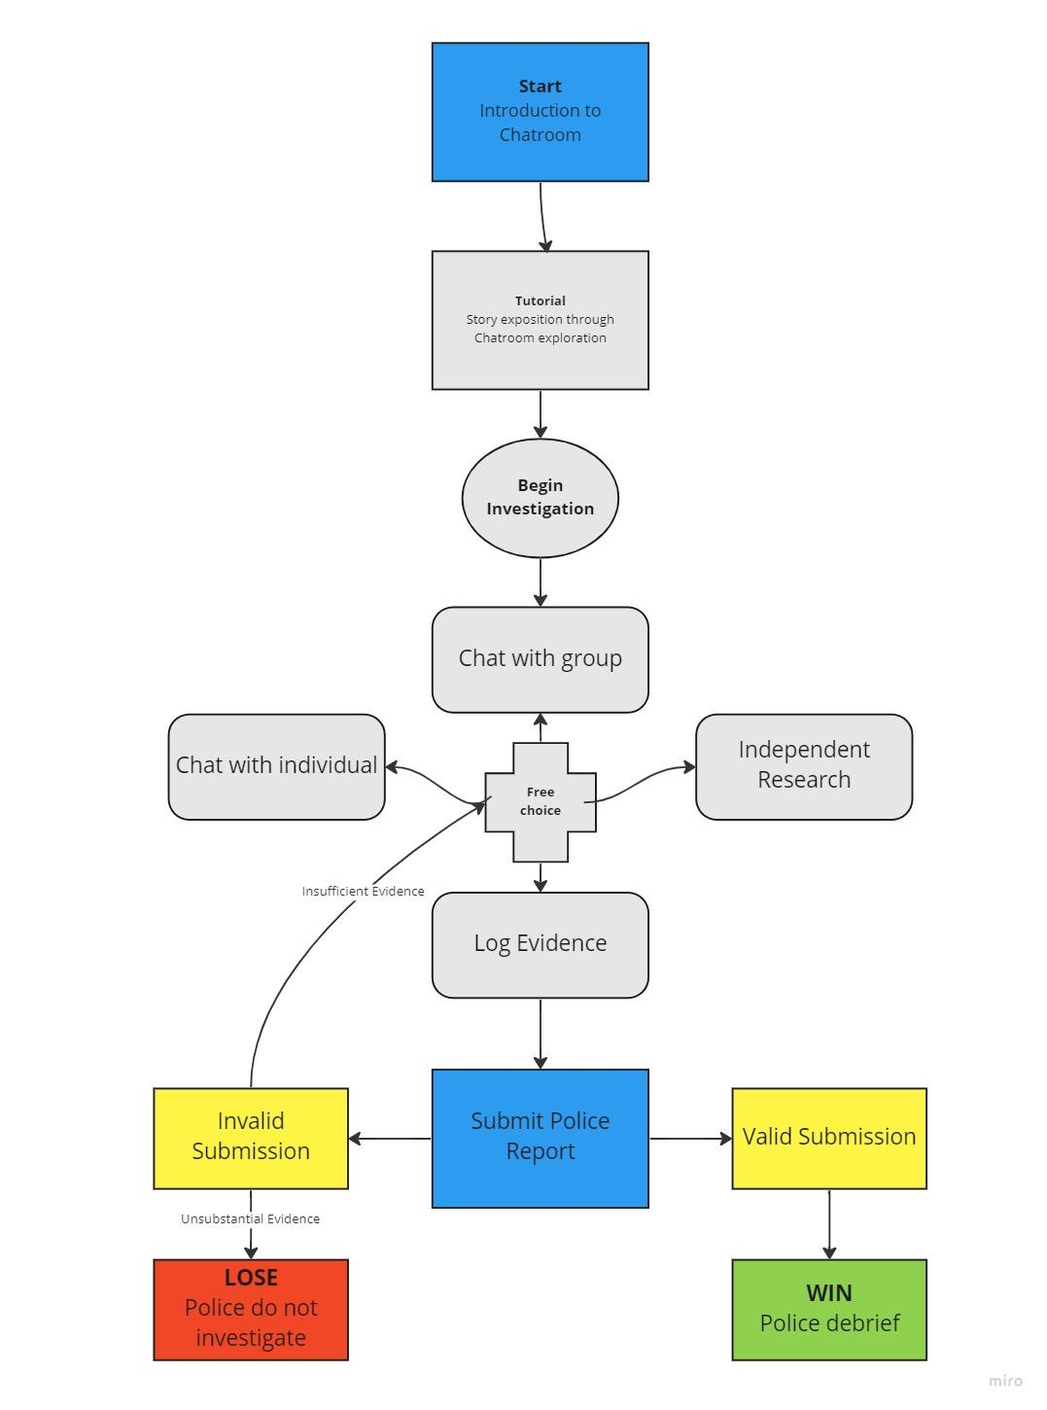

**Story (Adventure)**

Setting: 1920s Chicago (Bootleg mob)

Game Interface: IDK

Story: Young, ambitious, and without the means for an education, there are no other options for a quick profit. The game starts at the beginning of a very tumultuous bootlegging operation. The player, joins the bottom ranks of the most infamous mob in Chicago. There is no safe place as a member of a mob, but it seems that the player always ends up at the wrong place at the wrong time. During one of the player’s first pickups of imported alcohol, a police officer notices the player, revealing a crossroad. Escape jail by becoming a mole for the police and facing certain death by mob hit or kill the officer, bringing heat onto the entire operation but rising in rank. The player will face two such choices breaking the story into four potential vastly different endings. The game play between these choices will advance the story and feature simple skill based mini-games. One layer of story forking may be determined by the score of said mini-game(s). Exact narrative branches are TBD.

**Objects**

* Character Class
  + Officer1
  + Officer2
  + Senior mob member1
  + Senior mob member2
  + Foot soldier colleague
* Player
* Mini-game class
  + Collect liquor game
  + Attempt deception game(fun mechanism**)
* UI class
  + Menu
  + Settings
* Story branches class**
  + Branch1
  + Branch2
  + Branch3
  + Branch4

**Narrative Flow**

